John Abbott College

**Final Project**



Group 8

Craig Collins (1038789)

Iana Setrakova (2457647)

Prof. Stephanie Moreau

420-WE6-AB WEB DEVELOPMENT I

## July 2024

TABLE OF CONTENTS

TABLE 1

Planning and Preparation 2

Planning, steps performed 3

Wireframe 3

Data Model 4

E/R diagram 4

Target Audience 5

Research performed 6

Website Details 12

Git Hub Repository 13

GOAL and description 13

Communications 14

# Planning and Preparation

## Planning, steps performed

Our plan includes to choose the optimal design comprising essential features like user registration and task management. The webpages to be created are:

* Home page
* User log in
* Users sign up
* Dashboard to manage user profile and tasks
* Page showing a single task to be created or updated
* Contact us page

We need to enable PHP session when user logs in. And when session is created, user can

* Manage own profile
* Delete their account
* View the listing of to-do items
* Adding new to-do item
* Updating items
* Removing items
* Completing item

## Wireframe

Figma wireframe URL:

https://www.figma.com/design/aTDCn0tZJhNYUXIRgkhzXb/To-Do-List-Application?node-id=0-1&t=esHA8ZNBAmyIEVJJ-0

To add screenshots

## Data Model

* **Users**: Can create multiple tasks, each associated with only one user.
* **Tasks**: Belong to one list.
* **Lists**: Can have multiple tasks.
* **Reminders**: Each task can have one reminder.

EXTRA possible features for future development:

* **Tags**: Associated with one or multiple tasks.
* **Task Collaborators**: Enables multiple users to collaborate on a single task.

Database structure in Third normal form (3NF):

users = (id (PK), username, password, avatar_image, email)

tasks = (id (PK), name, description, task_order, *user_id (FK)*, *list_id (FK)*, due_date, completed)

lists = (id (PK), title, (extra possible column list_color)

reminders = (id (PK), *task_id (FK)*, reminder_time, repeat_interval, repeat_end_date)

Extra tables for future development:

tags = (id (PK), name, tag_color)

task_tags = *(task_id (FK), tag_id (FK)*)

task_collaborators = (id (PK), *task_id (FK)*, *user_id (FK)*)

Additional possible features:

Task to be “important”, “pinned”

To add checkbox “hide completed tasks”

## E/R diagram

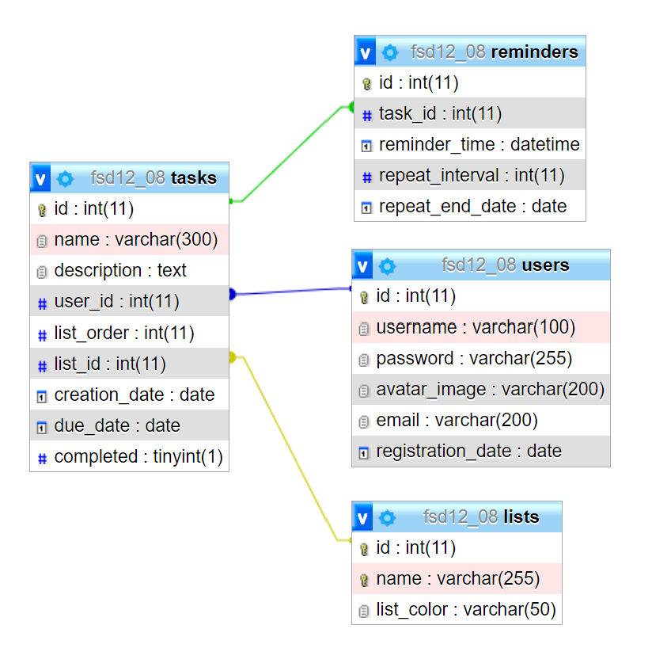

## Target Audience

1. Students:

To organize homework and study schedules.

1. Professionals:

To manage work tasks and project deadlines.

1. Home Organizers:

To keep track of household and family activities.

## Research performed

### Craig’s Research Notes

Best To-Do List Apps

* Todoist
* TickTick
* Microsoft To Do
* Apple Reminders
* Things
* Google Tasks
* Any.do
* (https://zapier.com/blog/best-todo-list-apps/)

**Common Features**

* Task creation, management, organization
* Due dates
* Reminders
* Priorities
* Categorization
* Recurring tasks
* Cross-platform syncing
* Collaboration
* Integration
* Notifications/Alerts
* Notes
* Attachments

**Common Appearance**

* User Friendly
* Minimalist/neutral tones
* Distraction-free colours
* Dark text against light backgrounds
* Primary colors for interactive elements, like buttons, icons and task indicator
  + Blue, red, green
* Secondary colours for additional emphasis, categories, and priorities
  + Orange, yellow, teal
* Pastels for highlighting list backgrounds, calendar views
* Colour coding
* Optional dark mode

**User Interface Elements**

* Task is usually in the center of the screen
* The navigation bar is usually a left sidebar and hamburger on mobile
* Add task buttons usually at the bottom-right corner of the screen, easily accessible
* Modal or side pane with task details to editing
* Search bar for easy searching
* Filter and sorting options
* User profile and settings

**Flowchart (preliminary)**

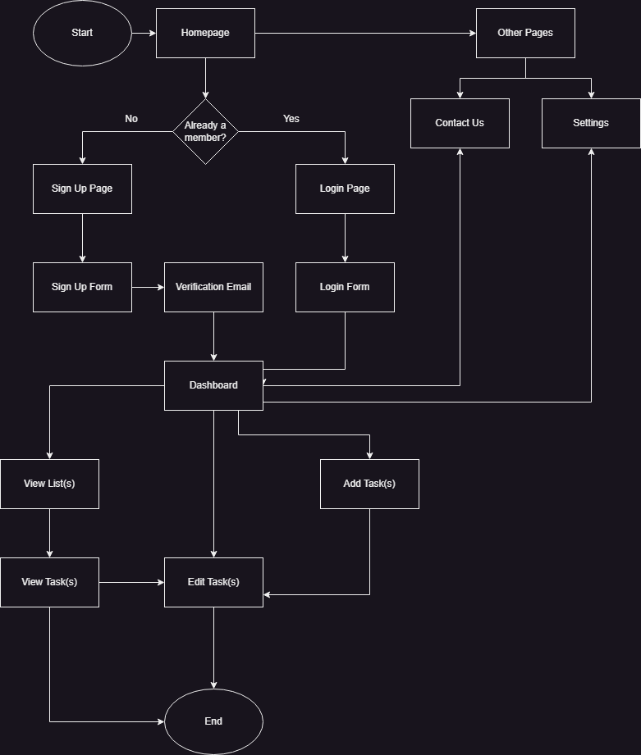

https://www.zenflowchart.com/guides/ux-flowchart

### Iana’s research:

<https://dribbble.com/shots/22373497-Create-a-task-Interaction>

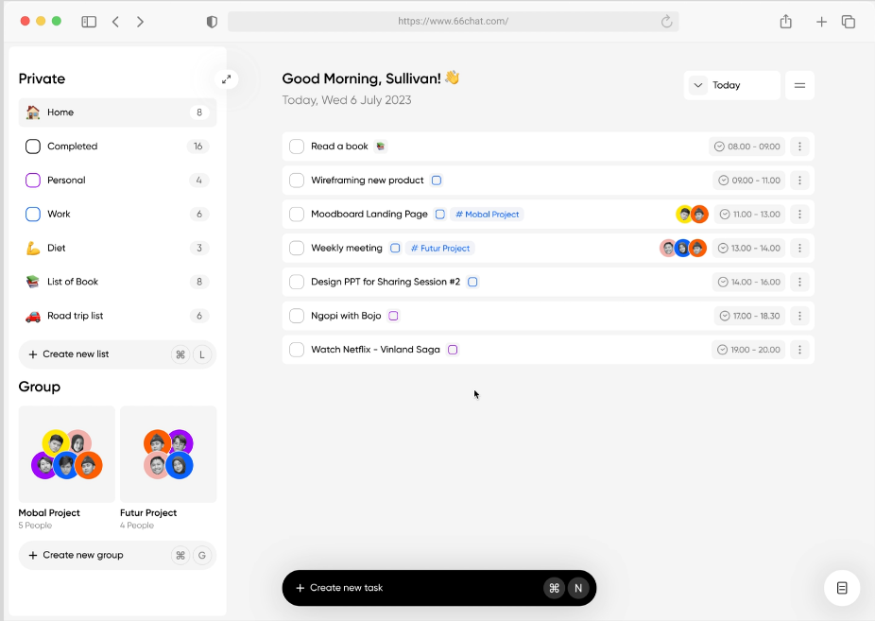

<https://todoist.com/>

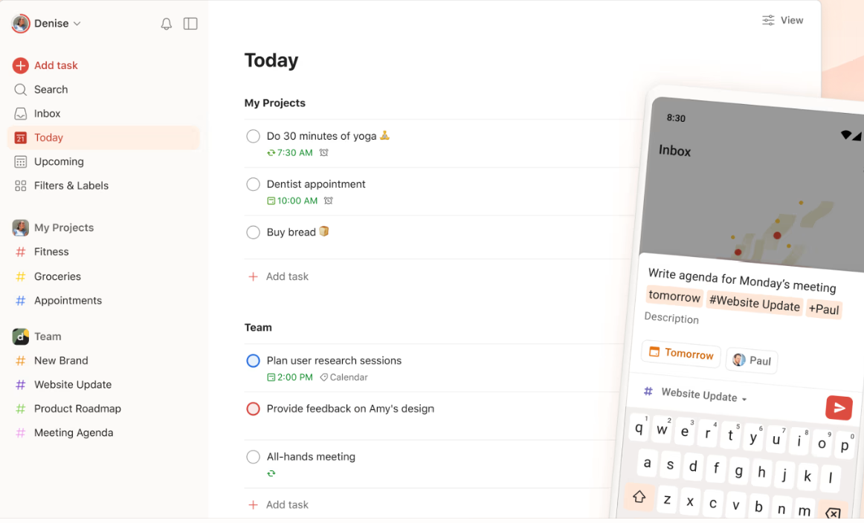

<https://www.any.do/>

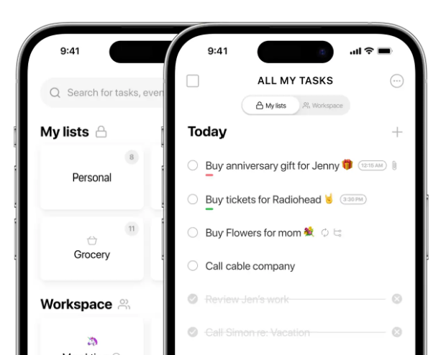

Microsoft To Do

https://to-do.office.com/tasks/

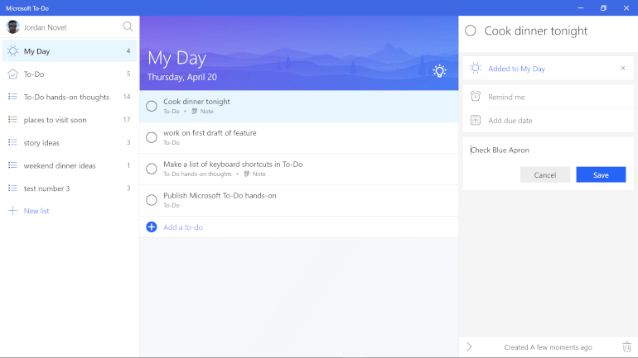

https://uxdesign.cc/got-stuck-with-to-do-list-i-create-a-new-app-819879fedce0

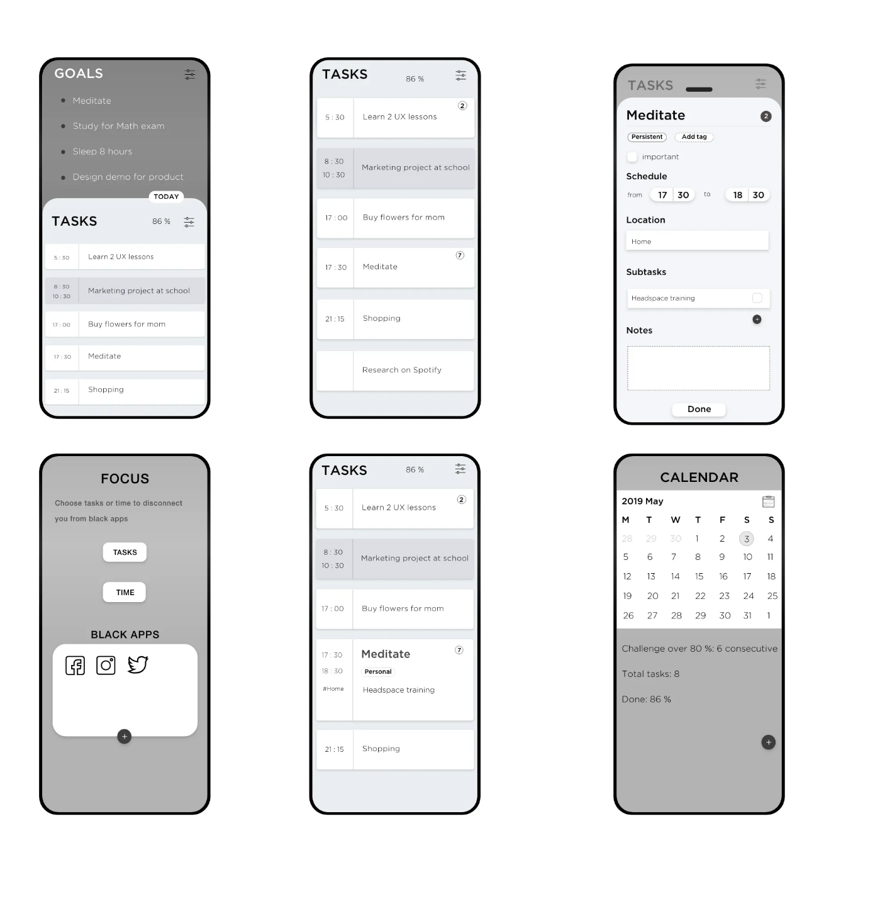

https://uizard.io/templates/website-templates/to-do-website/

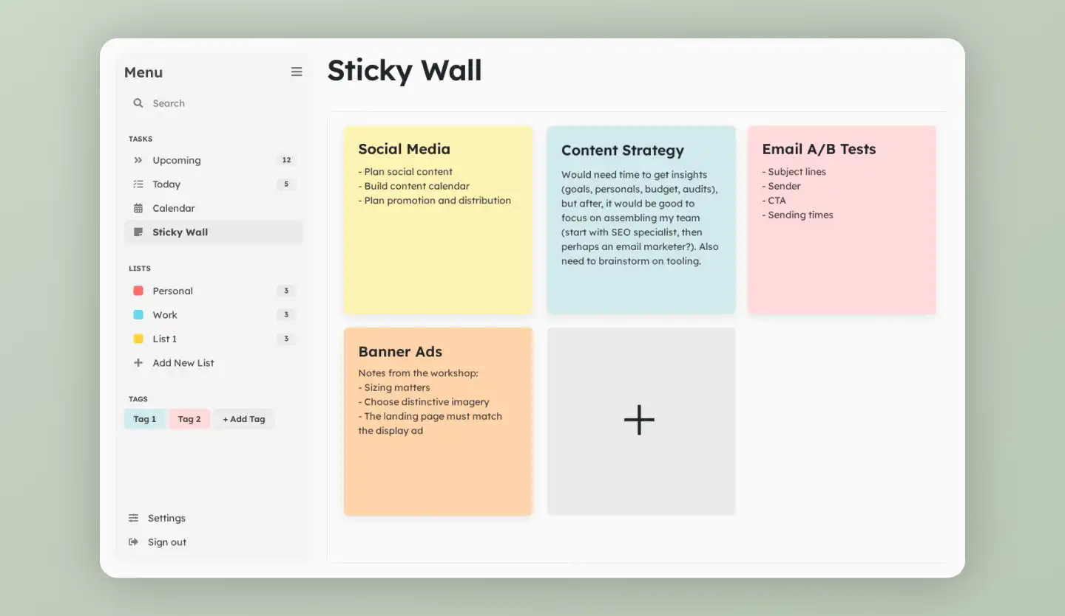

# Website Details

## Git Hub Repository

<https://github.com/iasssy/web-development-8>

## Goal and description

Overall Goal and purpose of the website description of website and additional feature and overall workflow

• Requirements

o How have you met the requested requirements of your topic

# Communications

Day 1

We got acquainted with team member’s background.

The tasks divided after the first meeting:

* Iana begins researching various To-Do List websites to gather insights for our project's database design, makes 3NF of database.
* Craig starts research on specific functionalities and started drafting the storyboard and flowchart to visualize the website's structure and user interactions.

Day 2

During our second team meeting:

* Craig shared the results of research on color palettes and decided to initiate work on the Contact Us page.
* Iana began creating a wireframe for the Homepage (Landing page), designed the logo, and decided to start the login and signup pages.
* We collaborated effectively in Figma, simultaneously working on the wireframe design for the Dashboard page.

• Post-Mortem

o What went wrong, what went right, what would you do different, how could you improve the website?

• Project Feedback

o Overall impression of the project, ways to improve the project.

o This is a general question, not related to your website.